
American International University-Bangladesh (AIUB)
Department of Computer Science
Faculty of Science &Technology (FST)
Fall 19-20
Section: J
Group No: 04
Job and Course Proposer
A software Engineering project submitted
By

Nayma Islam (18-36607-1) (Naiyma1997)
Ehsanul Haque (18-36572-1)(pro-coder-antik)
Shammi Akter(18-36445-1)(shammi-akter)
Anika Tahshin Meem (18-37662)(AnikaTahshin)

The project will be evaluated for the following Course Outcomes

CO3: Choose appropriate software engineering model in a software development environment | Total Marks
Project Background Analysis (needs, goal, benefits, etc.) [5Marks]
Appropriate Process Model Selection [5Marks]
Argumentation for model selection with Evidence [5Marks]
Completeness, Spelling, Grammar and Organization of the Answer [5Marks]
CO4: Explain the roles and their responsibilities in the software project management activities | Total Marks
Content Knowledge (e.g. System Requirements, System Design) [5Marks]
Project Role identification [5Marks]
Responsibility Description [5Marks]
Completeness, Spelling, grammar and Organization of the Answer [5Marks]

Contents
1. PROBLEM DOMAIN 4
1.1 Background to the Problem 4
1.2 Solution to the Problem 4
1.3 Existing / Related Solutions 5
2. SOFTWARE DEVELOPMENT LIFE CYCLE 5
2.1 Process Model 5
2.2 Project Roll Identification and Responsibilities 5
3. PRODUCT AND PROJECT DESCRIPTION 6
3.1 Stakeholders 6
3.2 System Features 7
4. System Quality Attributes 9
4.1 System Architecture 10
4.2 System Interface 16
4.3 Project Requirements 18

PROBLEM DOMAIN

Background to the Problem

The number of frustrated Engineers is increasing day by day due to their lack of understanding the perspective of the subject. One of the hyped lines that every university student gets to hear during their university life is there is no job in the market of Computer Science. There are many students in this field who still doesn’t know the real purpose of Computer Science or why they’re studying in this filed. They often get confused on what they should focus more what goals they should set and what their next move should be. This Application will help the students get a clear vision on how to complete courses step by step and acquire skills also students can avail part time and full time available jobs with the help of this Application.
Scenario:
A student named “X” after completing his HSC got himself admitted in Computer Science but, after continuing a few semesters he got confused on what he should focus more in order to build his skills. Which courses he should enroll and focus more. At the same time he was going looking forward to a few job requirements he got demotivated knowing he still has a lot of lacking to get himself ready for the kind of job he’s seeking for.

Solution to the Problem
Our job and course proposer is an app which will give the user suggestions depending on how many credits or courses a student has completed and the job preference of the student. Nowadays a student has to face many problems to get desired job after completing his graduation. Most of the time the scenario is a student doesn't have enough knowledge on what he has to do with the degree or he is not qualified enough for the desired job because he doesn't meet the job requirements. So this app will sort out this kind of problems. It'll help the students to be prepared for his desired job based on CS by providing course suggestions & the job requirements details. After getting clear concept a student may want to enroll courses. But he may also face difficulties while choosing from where he should enroll courses. This app will help him to choose from where he should enroll courses. This app will provide a list of organizations and the course fees to avail the courses he can change wisely for which price range he should go for. A list of full time and part time job will be provided in this app for the students so they can avail according to their preference. Since the ratio of fresh unemployed graduates are higher, our main motive through building this app is to minimize the ratio by helping students giving them a guideline based on what to do in the available time and utilizing it wisely so that when he becomes a graduate he wouldn't have to face difficulties for searching a job.

Existing / Related Solutions
Currently we’ve a few existing solutions to the project we proposed those solutions individually carries either course or job, and the job existing in their application most of the time aren’t authentic or reliable. Our Application is different from the existing solutions because this application will help students to understand the importance of the courses they’ll enroll, also help student give a clear vision on their next step, besides if they have requirements meeting to the job available in the application they can avail them just by dropping their CV.

SOFTWARE DEVELOPMENT LIFE CYCLE

Process Model
The kind of applications we’ll be building will have requirements for courses and jobs. This model is going to be designed to assist the customer in understanding the requirements.
The software that we’re going to be using for the application is an Incremental Model. Incremental Model is a process of software development where requirements are broken down into multiple standalone modules of software development cycle. A customer can respond to each building. It is flexible and less expensive to change requirements and scope. The Client gets important functionality early.
Since this is an application based problem this is going to be a small project which is comparatively going to be less expensive. So this model is less costly compared to other models and throughout the development stages changes can be done. A customer can respond to each building, errors are easy to be identified. The Client gets important functionality early so this application is more flexible.

Project Roll Identification and Responsibilities
Incremental Model is a process of software development where requirements are broken down into multiple standalone modules of software development cycle. Incremental development is done in steps from analysis design, implementation, testing/verification, maintenance.
Each iteration passes through the requirements, design, coding and testing phases. And each subsequent release of the system adds function to the previous release until all designed functionality has been implemented.
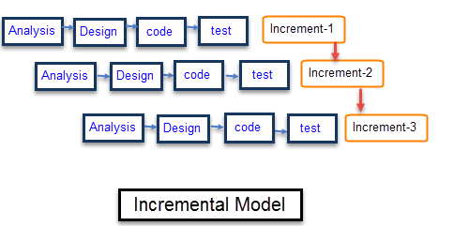

Characteristics of an Incremental module includes
- System development is broken down into many mini development projects
- Partial systems are successively built to produce a final total system
- Highest priority requirement is tackled first
- Once the requirement is developed, requirement for that increment are frozen

PRODUCT AND PROJECT DESCRIPTION

Stakeholders
Internal Stakeholder:
Stakeholder Name | Organization | Role
Nayma Islam | SW Farm | Product Owner
Gazi Ehsanul | SW Farm | Scrum Master
Shammi Akter | SW Farm | Development Team
Anika Tahsin | SW Farm | Manager

External Stakeholder:

Stakeholder Name | Organization | Role
Osama Bin | JCP | President
Ayman Zawahiri | JCP | Treasurer
Abu Zarqawi | JCP | Secretary
Hamza Bin | JCP | Member
Abu Masri | JCP | Vice President

System Features
Functional Requirements
- 1. Registration: Every student must have to sign up and create an account to that application in order to get access to all the facilities to our software.
- 2. Log in: After completion of their registration they can log in to their respective accounts and check all the updates of newly arrived jobs and courses.
- 3. Set Constraints: After selecting any options from the list provided in our system, we can also set additional conditions as per need. For example while selecting a course we can also set location and range of money we want to pay for a particular course.
- 4. Auto Checker: The software will scan results as well as credit completed from each student and match it with all the jobs or courses. After that it determine which jobs or courses are eligible for that user. Then it shows all the filter results.
- 5. Edit User: All of the users will have the option to edit their profile. For example they can change their name, number of courses completed as well as their results. Moreover they also have the option to delete their account from the server.

- Priority Level: High
- Precondition: user has valid user id and password

System Quality Attributes
- Usability: The App shall be secure from hackers.
- Adaptability: This App is user friendly for students they’ll have a clear vision on what courses they shall focus more and how they shall prepare themselves for the job available.
- Recoverability: The website shall be backed up nightly and be able to be restored on one hour’s notice.
- Safety: Student’s information will be secured within the application.
- Affordability: Students will be able to enroll courses that are free of cost.
- Customizability: Students shall be able to customize their CV and put their grades after completing courses.

System Architecture:
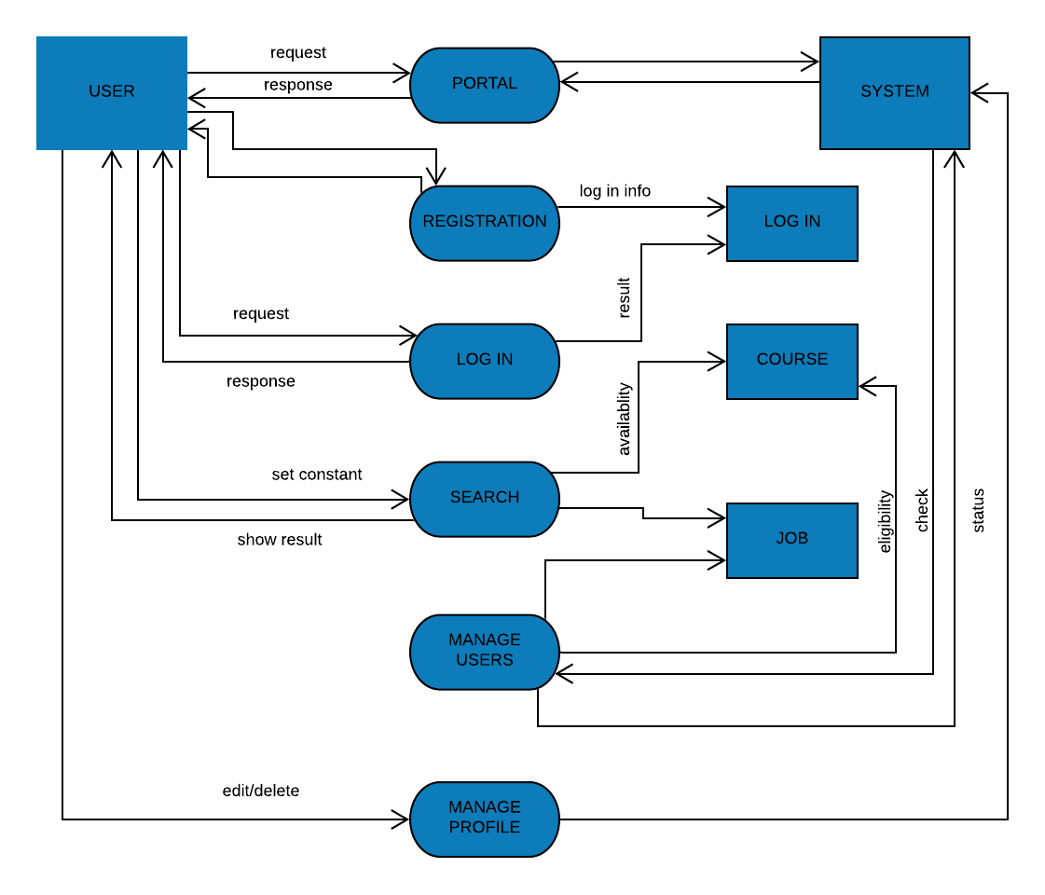
FIG: DATA FLOW DIAGRAM
4.1(a) DATA FLOW DIAGRAM:

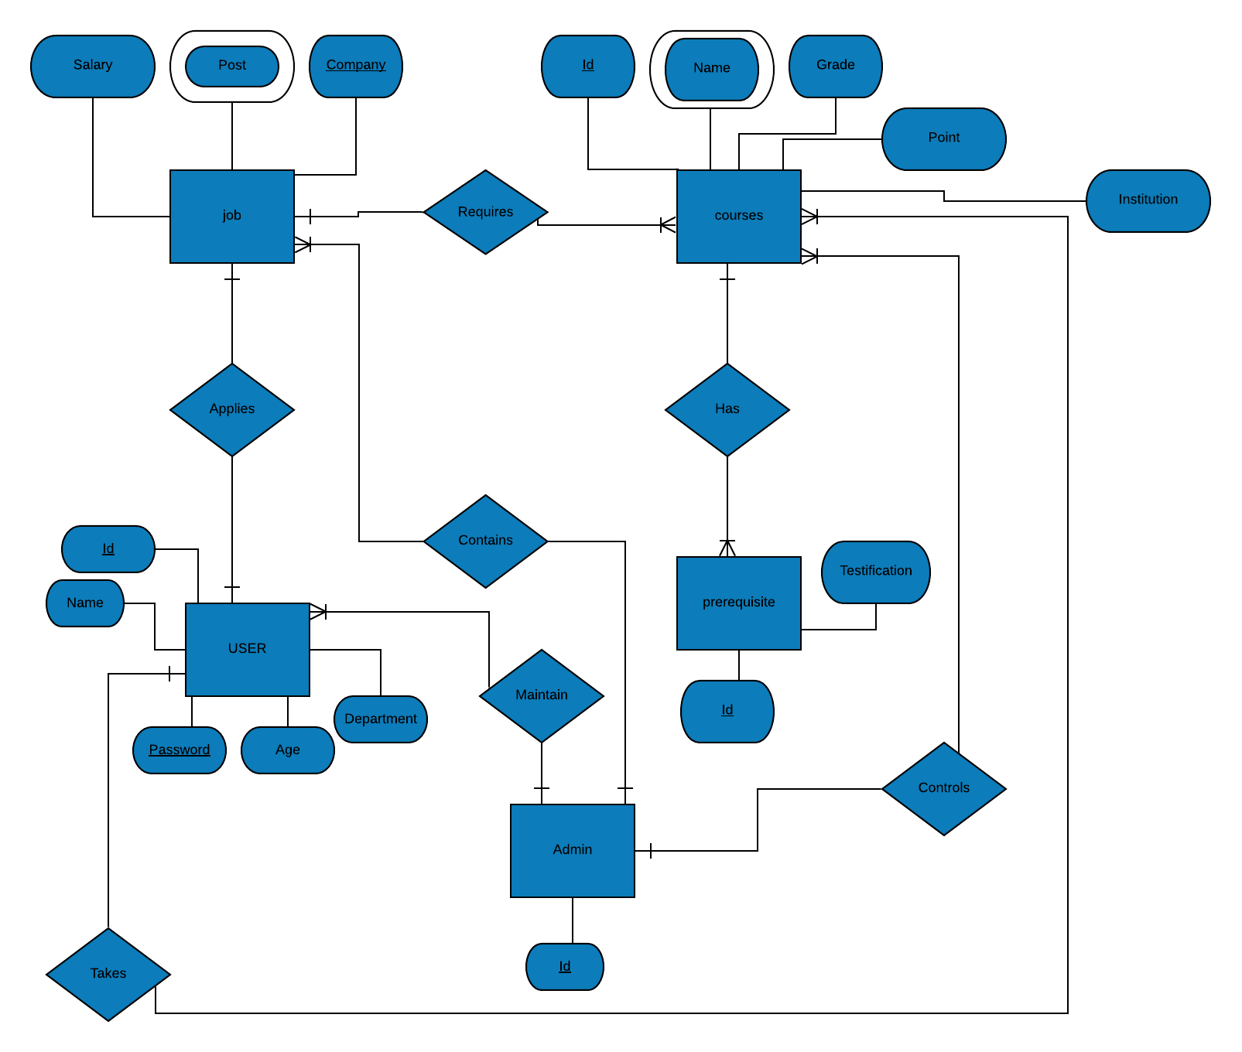
4.1 (b) ENTITY RELATION DIAGRAM:
FIG: ENTITY RELATION DIAGRAM
FIG: ACTIVITY DIAGRAM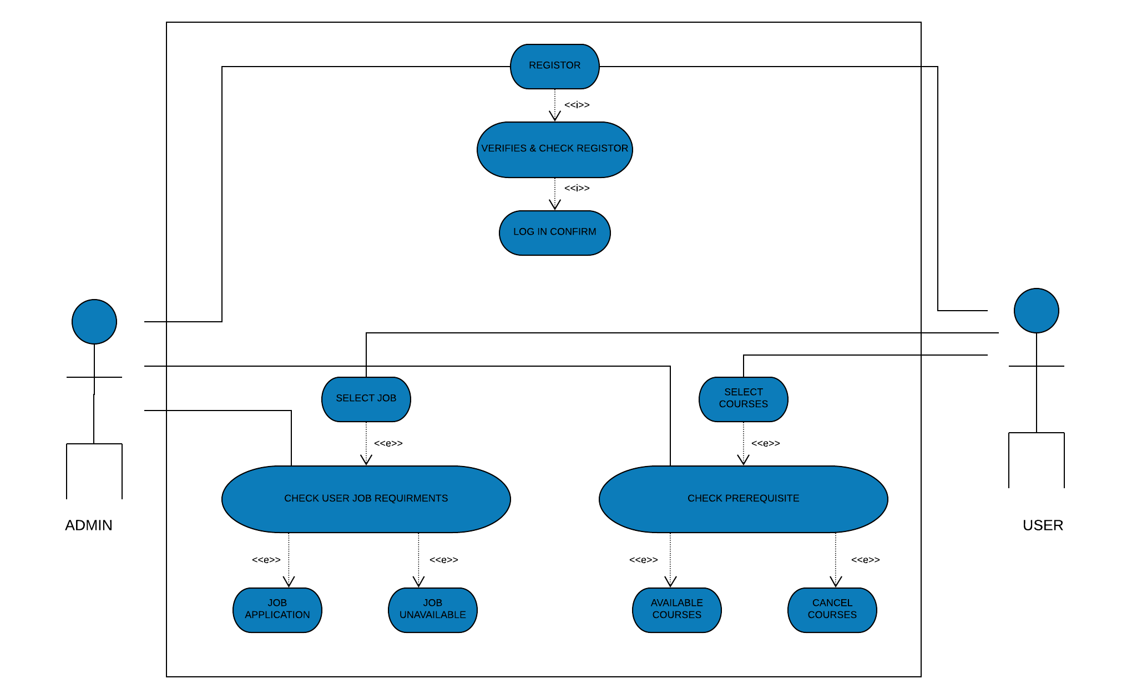
4.1(c) USE CASE DIAGRAM:
FIG: USE CASE DIAGRAM

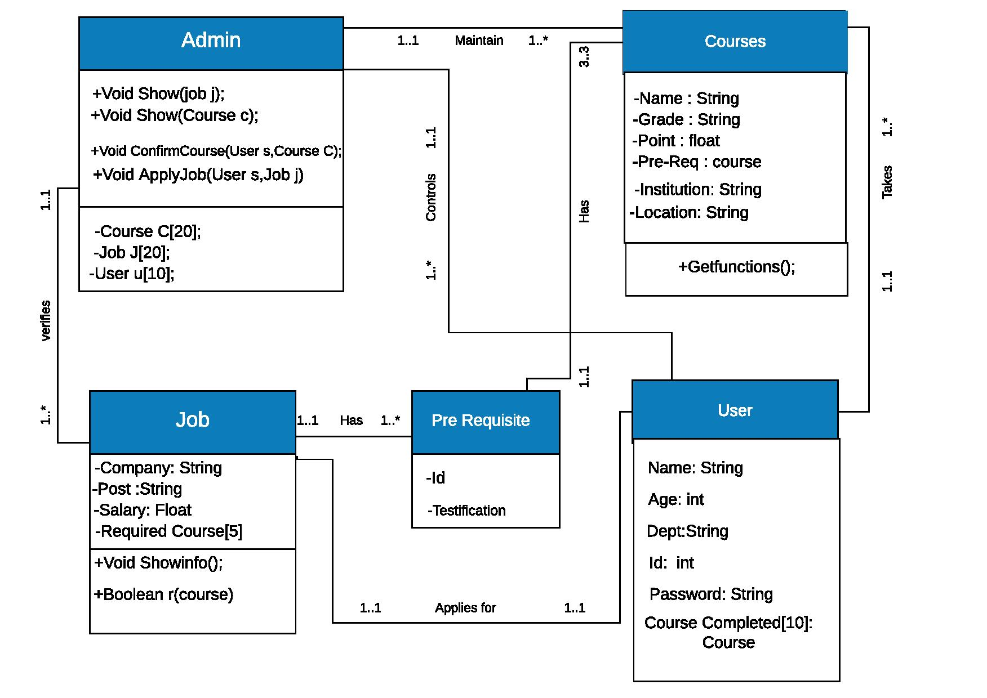
4. 1(d) CLASS DIAGRAM:
FIG: CLASS DIAGRAM
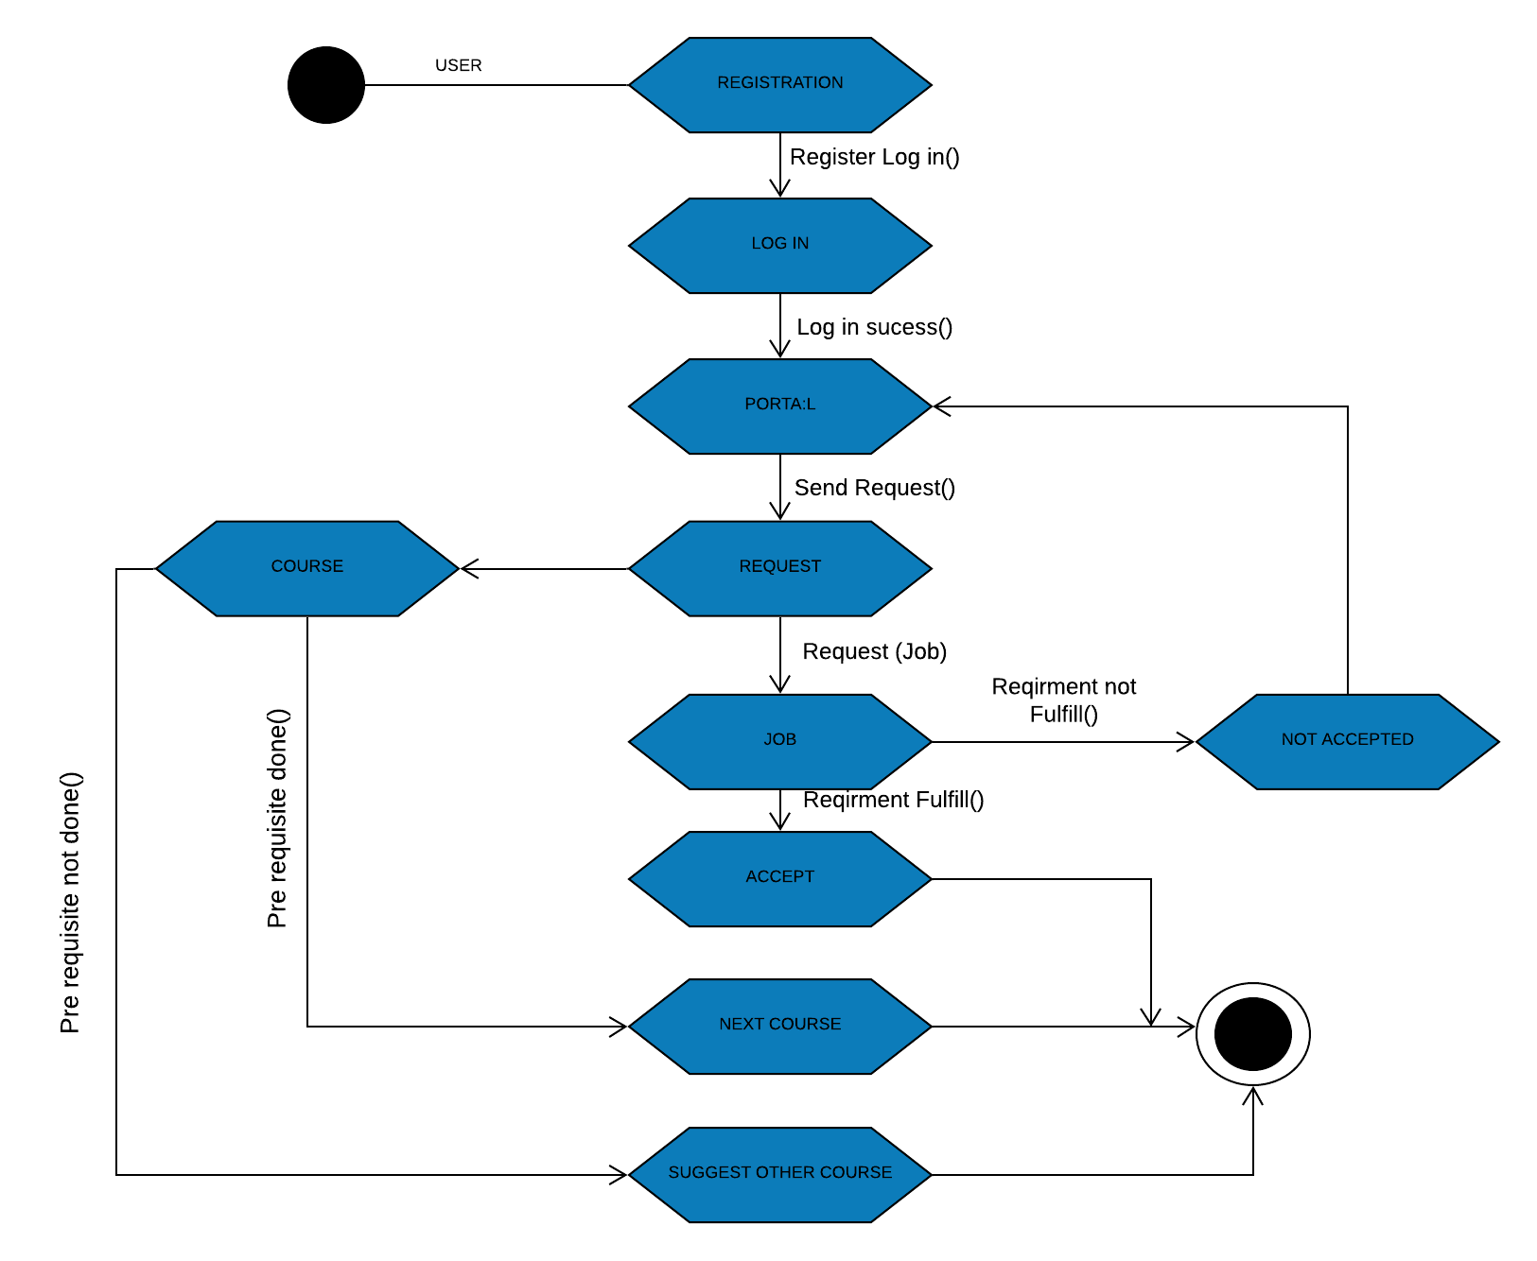
4.1(e) STATECHAR DIAGRAM:
FIG: STATECHAR DIAGRAM

System Interface
Draw the system interface where the users [Type a quote from the document or the summary of an interesting point. You can position the text box anywhere in the document. Use the Text Box Tools tab to change the formatting of the pull quote text box.]
- will interact with the system’s functionality.
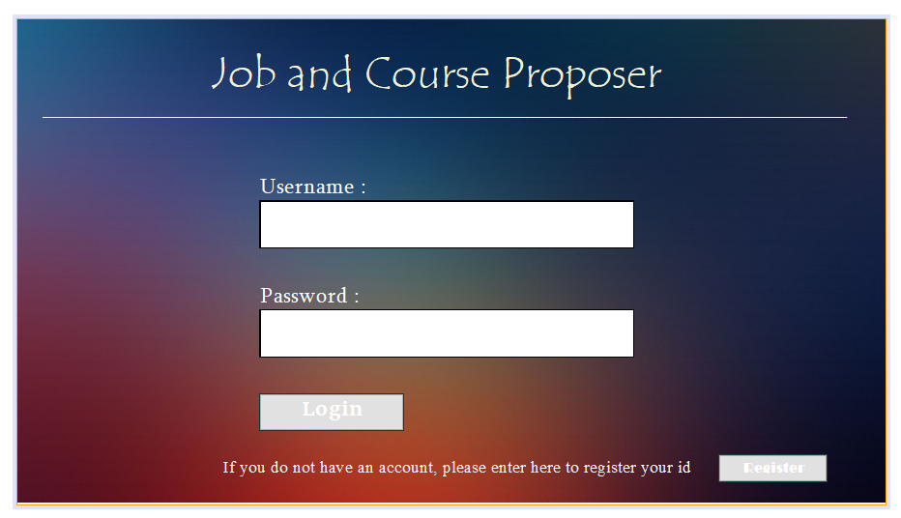
FIG: LOG IN PAGE
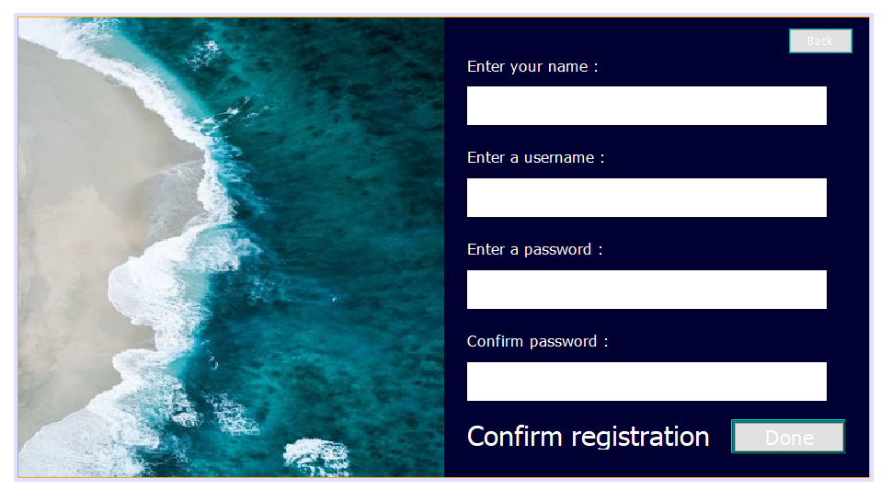

FIG: REGISTRATION PAGE

Project Requirements

Requirement ID | Requirement Statement | Must/Want | Comments
R001 | This App shall cost less than $1000 to be built.
R002 | It’ll take 90 to 120 days to complete this project. | Must
R003 | System designer, Programmer, testing team, risk analysis team are the resources in this project | Must
R004 | This is an Organic mode project with a 2-50k LOC | Must
R005 | Since it is a low budget project we’re assuming there’ll be no organization, tool or estimation risk. | Must
R006 | Nature of project size is small, since this is an inventory project. | Must
R007 | The deadline of this project is not tide

Reference:
Guru99, Roger S. Pressman, Hans van Vliet. Software Engineering: Principles and Practice (Second Edition).

